Placement Test
in Big Data Analytics

Full Name: Blerta Hoxha
Student id:

Question 1
Write a Python program to create a Histogram by using the data that are provided in the following array:
data = [21,22,23,4,5,6,77,8,9,10,31,32,33,34,35,36,37,18,49,50,100]
Tips: a.Use matplotlib for creating the Histogram, b. Use 5 bins (intervals / classes)

Answer
import numpy as np
import matplotlib.mlab as mlab
import matplotlib.pyplot as plt

data = [21,22,23,4,5,6,77,8,9,10,31,32,33,34,35,36,37,18,49,50,100]

num_bins = 5
plt.hist(data, num_bins, facecolor='blue', alpha=0.7, edgecolor='red');

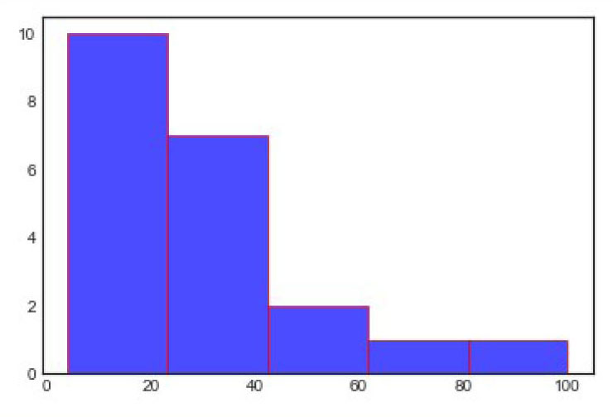
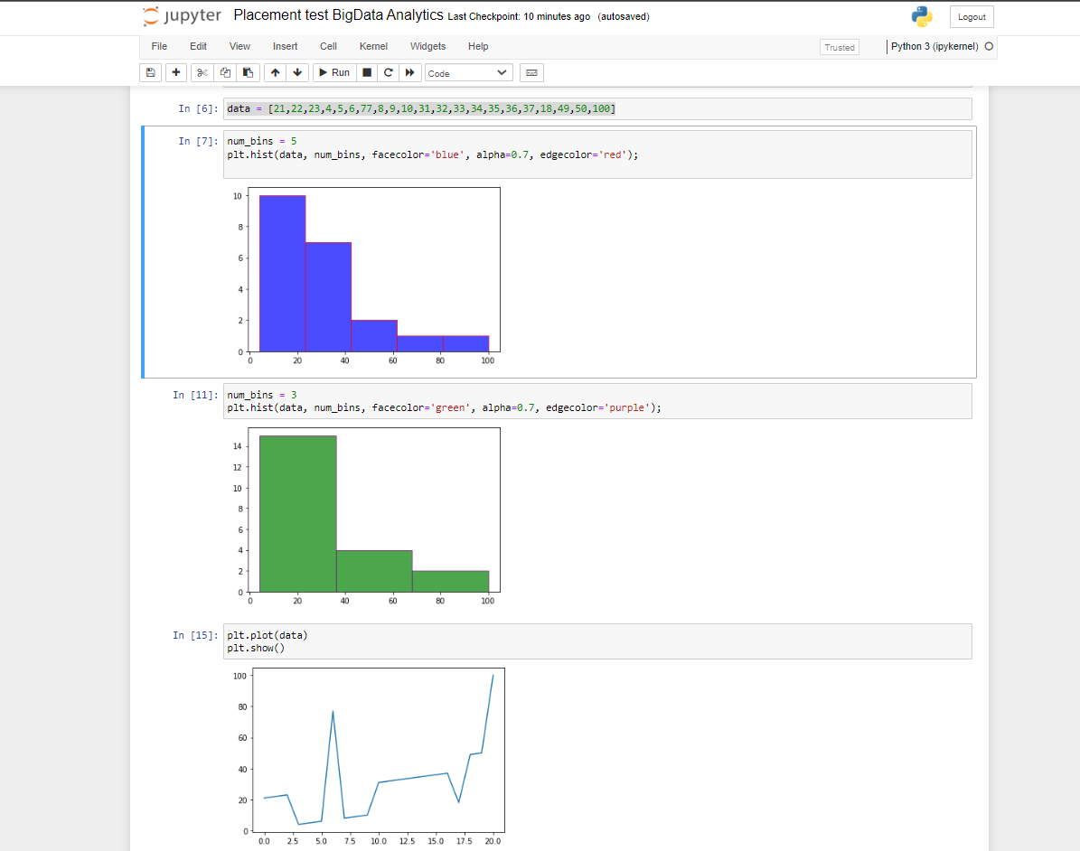

Question 2
Create an array of 5 values evenly spaced between 0 and 1 by using NumPy and linspace

Answer
import numpy as np
np.linspace(0, 1, 5)
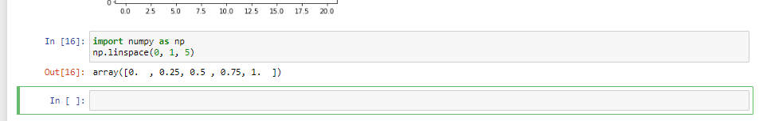

Question 3
Create a NumPy array of size 10, populated with random integer numbers that take value in the interval [0, 9]

Answer
import numpy as np
x = np.random.randint(10, size=10)
x

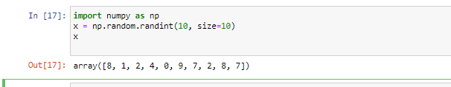
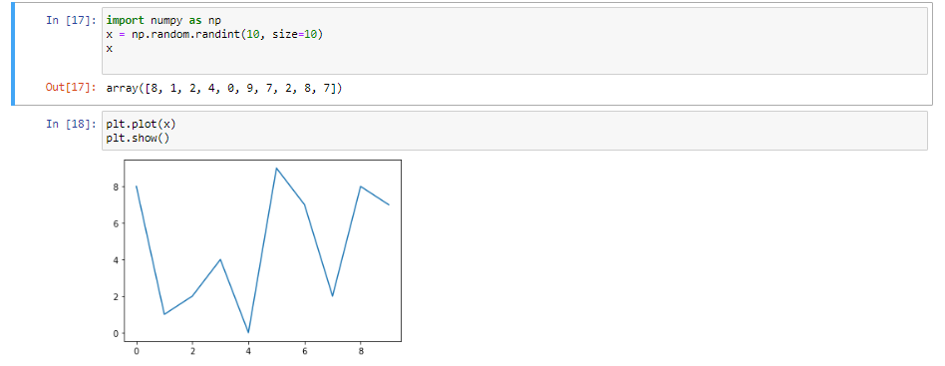

Question 4
Sort from min to max value the previously generated in Question 3, NumPy array

Answer
import numpy as np
x2 = np.sort(x)
x2

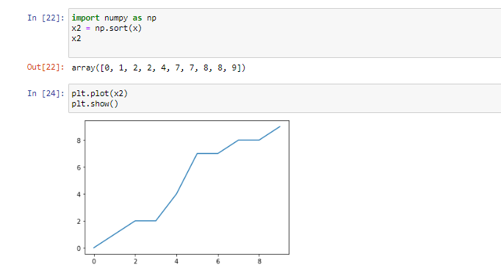

Question 5
Reverse the elements of the following array:
x = [37, 18, 49, 50, 100, 21, 32, 37, 18, 49, 50, 100, 22, 23, 6, 5, 4, 77, 8, 9, 10, 31]

Answer
x[::-1]
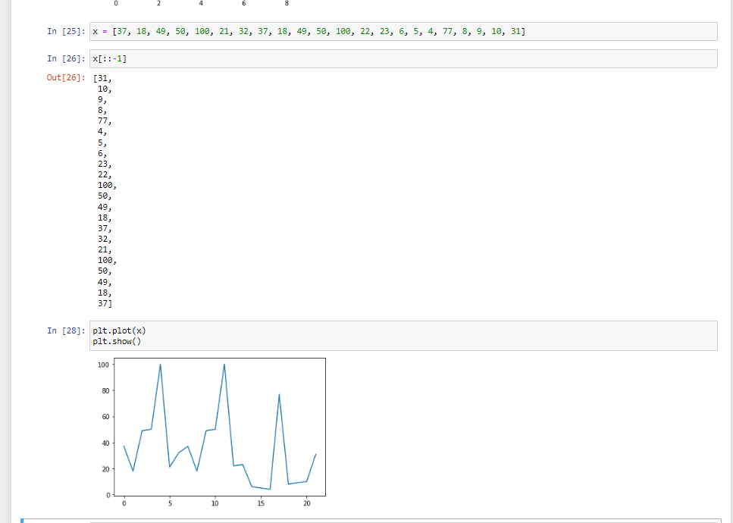

Question 6
Read the csv file that is provided (BP.csv) using Pandas

Answer
import pandas as pd
data = pd.read_csv('c:\python_code\class_material\BP.csv')
print(data)

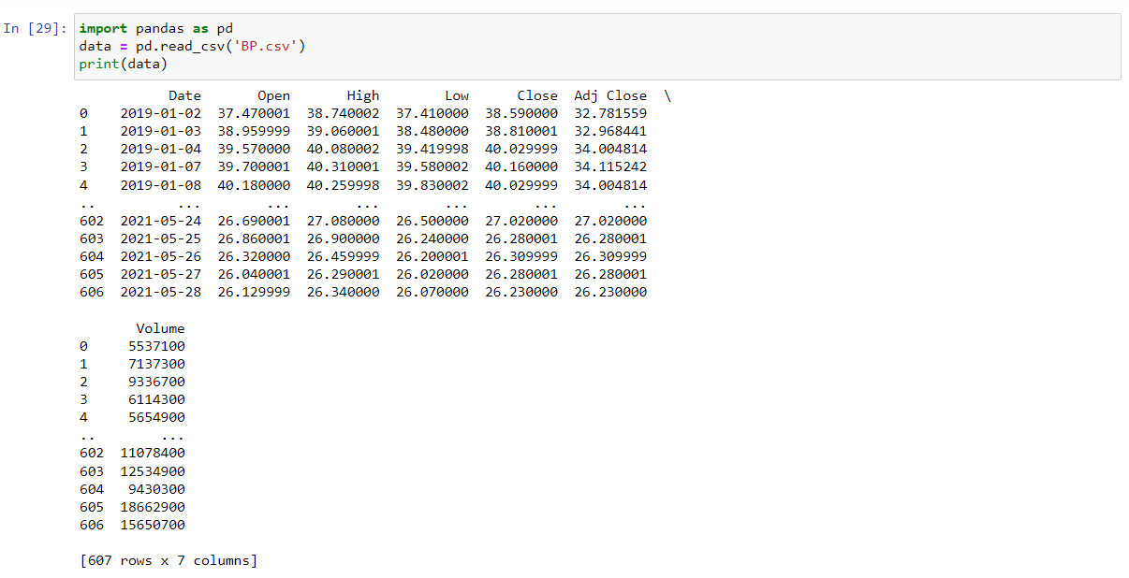

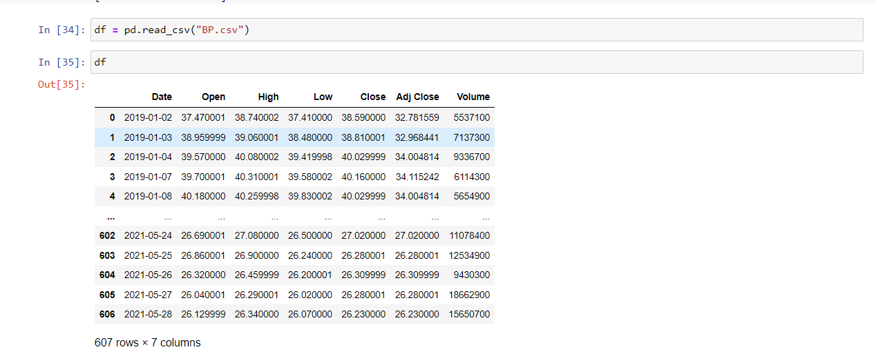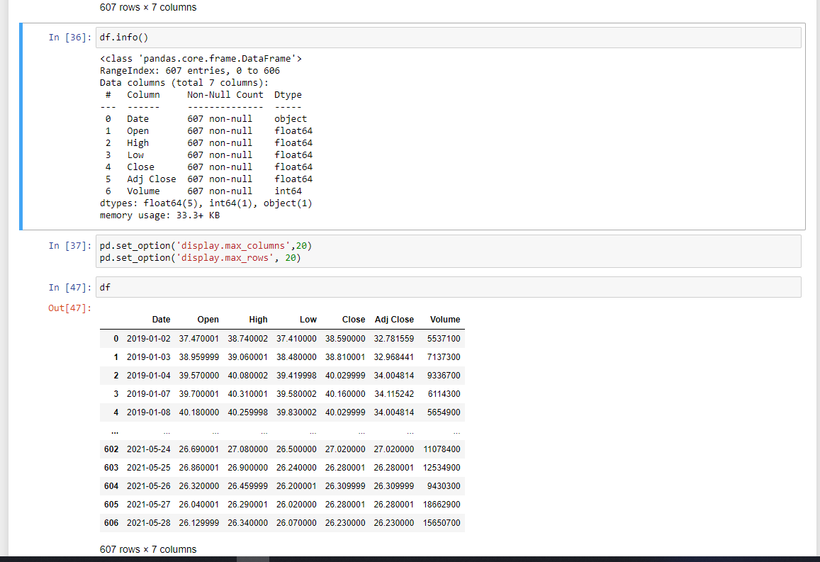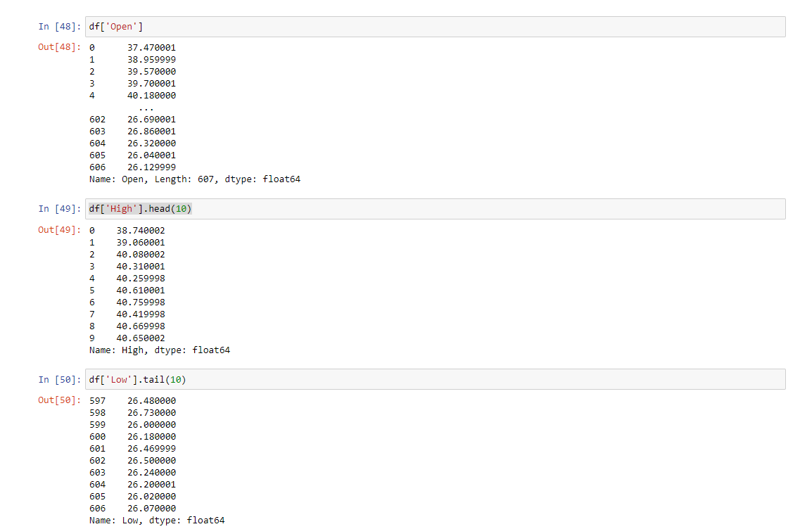

Question 7
Read only the following 2 columns: ‘Date, Adj Close from the csv file that is provided (BP.csv) using Pandas

Answer
import pandas as pd
cols_to_read = ['Date', 'Adj Close']
data = pd.read_csv('c:\python_code\class_material\BP.csv', usecols=cols_to_read)
data.head()

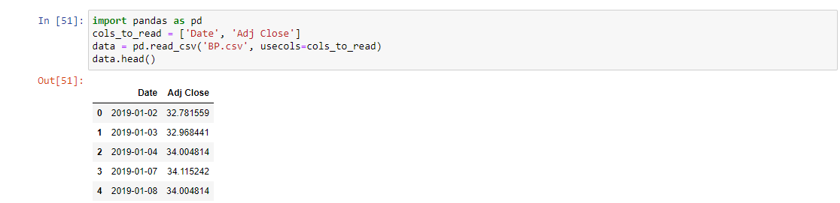

Question 8
Read the first 10 lines of the csv file that is provided (BP.csv) using Pandas

Answer
import pandas as pd
# read only 10 rows of data
data = pd.read_csv('c:\python_code\class_material\BP.csv', nrows=10, sep='\t')
data

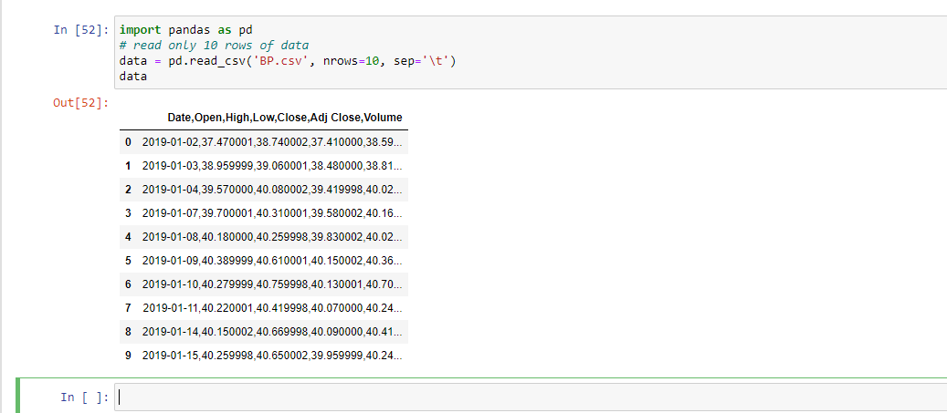

Question 9
Set column “High” as index in the csv file that is provided (BP.csv) using Pandas

Answer
import pandas as pd
# Setting one column as Index
data = pd.read_csv('c:\python_code\class_material\BP.csv', index_col=2)
data.head()

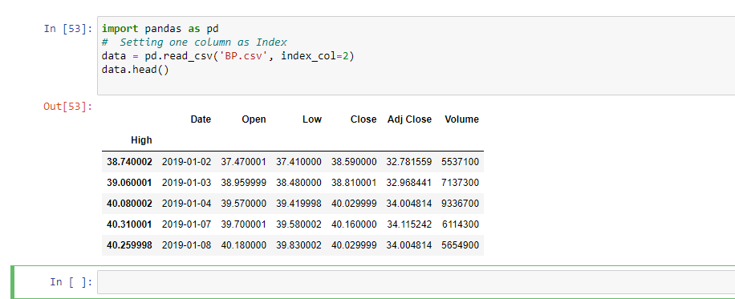

Question 10
Read the columns “Open”, “Close” and “Volume” of the csv file that is provided (BP.csv) using Pandas. Furthermore, calculate the following statistics, only for the column “Open”
- Mean
- Standard deviation
- Minimum
- Maximum
- Index of Minimum
- Index of Maximum
- 25th percentile
- Median
- 75th percentile

Answer
import pandas as pd
import numpy as np
# only read selected columns
cols_to_read = ['Open', 'Close', 'Volume']
data = pd.read_csv('c:\python_code\class_material\BP.csv', usecols=cols_to_read)
open_price = np.array(data['Open'])
# print(open_price)
print("Mean open_price: ", open_price.mean())
print("Standard deviation:", open_price.std())
print("Minimum open_price: ", open_price.min())
print("Maximum open_price: ", open_price.max())
print("Index of Minimum open_price: ", open_price.argmin())
print("Index of Maximum open_price::", open_price.argmax())
print("25th percentile: ", np.percentile(open_price, 25))
print("Median: ", np.median(open_price))
print("75th percentile: ", np.percentile(open_price, 75))
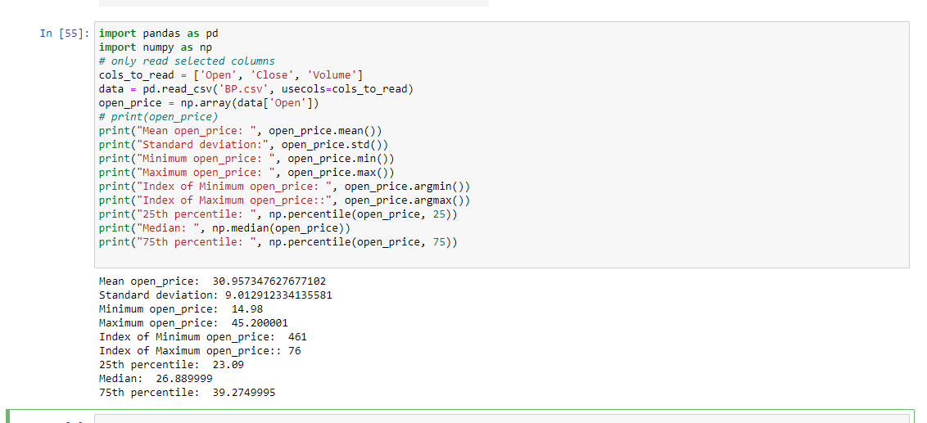

Question 11
Read the “Open” prices of the csv file that is provided (BP.csv) using Pandas and create the Histogram of “Open” prices by using matplotlib. Moreover, provide a title for the histogram and name the x and y labels

Answer
import pandas as pd
import numpy as np
import matplotlib.pyplot as plt
import seaborn; seaborn.set() # set plot style

data = pd.read_csv('c:\python_code\class_material\BP.csv')
open_price = np.array(data['Open'])
plt.hist(open_price) # Histogram
plt.title('Distribution of stocks Open Prices')
plt.xlabel('Stock Prices')
plt.ylabel('Number of observations');

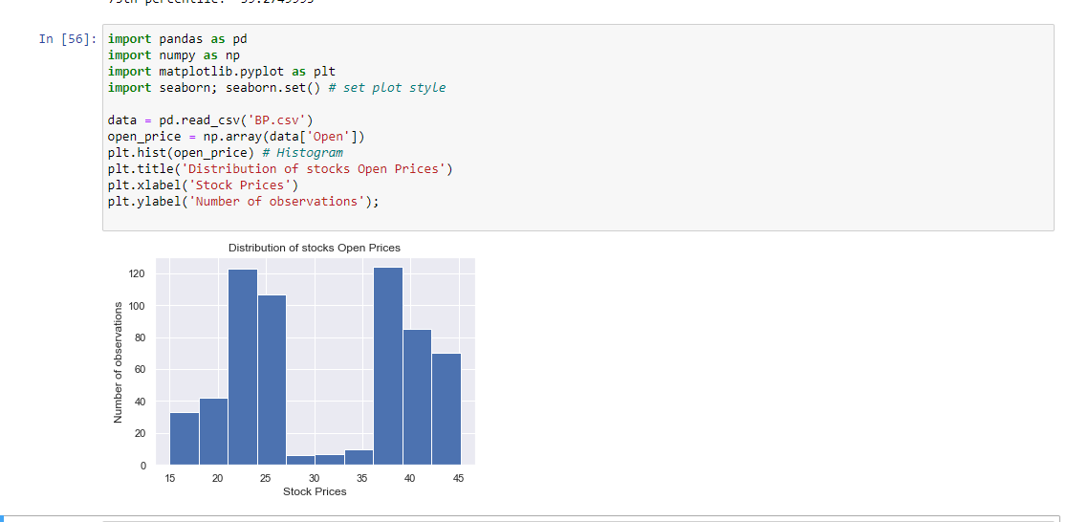

Question 12
Remove the 4th item from following list and add the same item in 2nd index
x = [34, 54, 67, 89, 11, 43, 94]

Answer
print("Original list ", x)
# pop(index): Removes and returns the item at the given index from the list
element = x.pop(4)
print("List After removing element at index 4 ", x)

x.insert(2, element)
# insert(index, item): Add the item at the specified position(index) in the list
print("List after Adding element at index 2 ", x) 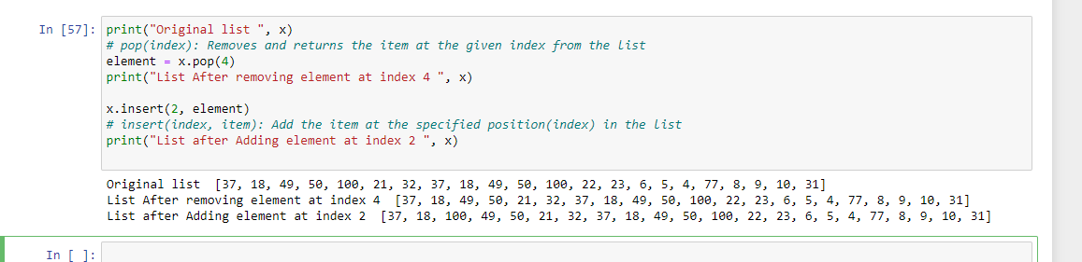
Question 13
Count the occurrence of each element from the list x = [11, 45, 8, 11, 23, 45, 23, 45, 89]

Answer
# Count the occurrence of each element from a list
x = [11, 45, 8, 11, 23, 45, 23, 45, 89]
print("Original list ", x)

# create a dictionary to show the count of each element
count_occurrence = dict()
for item in x:
if item in count_occurrence:
count_occurrence[item] += 1
else:
count_occurrence[item] = 1

print("Printing count of each item ", count_occurrence)

